**GGlot2 2**

**Data set mpg**

qplot(displ, hwy, data = mpg, geom=c("point", "smooth"),facets=.~drv)

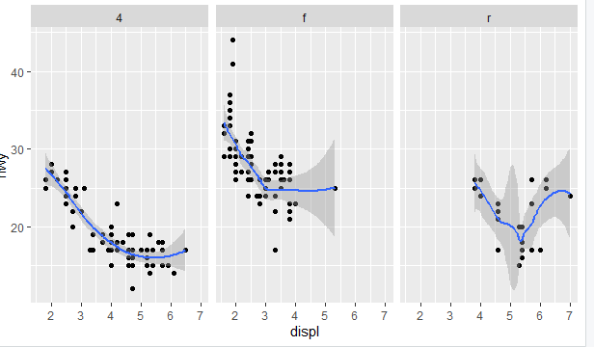

g <- ggplot(mpg, aes(displ,hwy) )

g+geom_point()+geom_smooth(method="lm") + facet_grid(.~drv)+ ggtitle("Swirl Rules!")

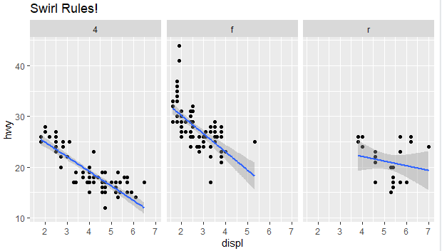

g + geom_point(aes(color = drv)) + labs(title="Swirl Rules!") + labs(x="Displacement", y="Hwy Mileage")

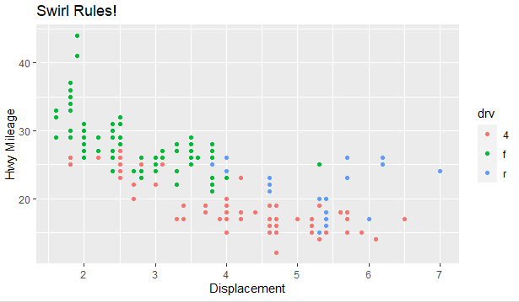

g + geom_point(aes(color = drv),size=2,alpha=1/2) + geom_smooth(size=4,linetype=3,method="lm",se=FALSE)

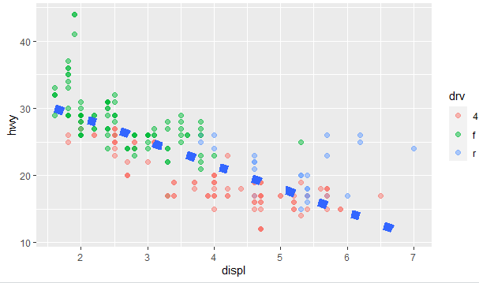

g + geom_point(aes(color = drv)) + theme_bw(base_family="Times")

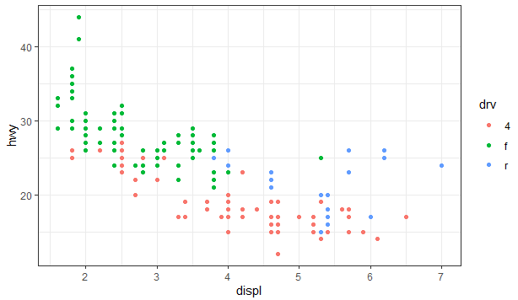

| We've created some random x and y data, called myx and myy, components of a

| dataframe called testdat. These represent 100 random normal points, except

| halfway through, we made one of the points be an outlier. That is, we set its

| y-value to be out of range of the other points. Use the base plotting function

| plot to create a line plot of this data. Call it with 4 arguments - myx, myy,

| type="l", and ylim=c(-3,3). The type="l" tells plot you want to display the data

| as a line instead of as a scatterplot.

plot(myx, myy, type = "l", ylim = c(-3,3))

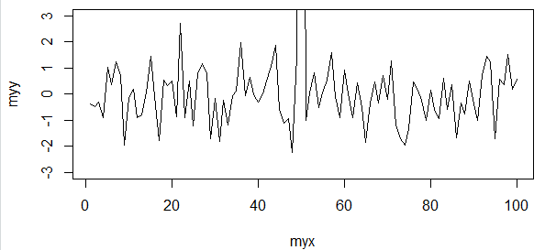

g <- ggplot(testdat, aes(x = myx, y = myy))

g + geom_line() + coord_cartesian(ylim=c(-3,3))

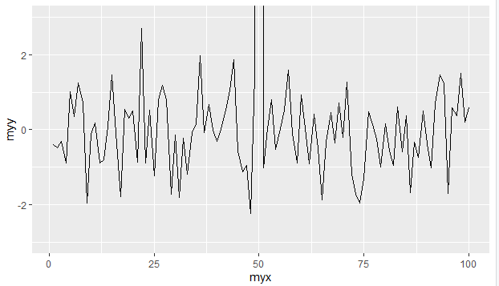

g <- ggplot(mpg,aes(x=displ,y=hwy,color=factor(year)))

g + geom_point() + facet_grid(drv~cyl,margins=TRUE)+geom_smooth(method="lm",size=2,se=FALSE,color="black")+labs(x="Displacement",y="Highway Mileage",title="Swirl Rules!")

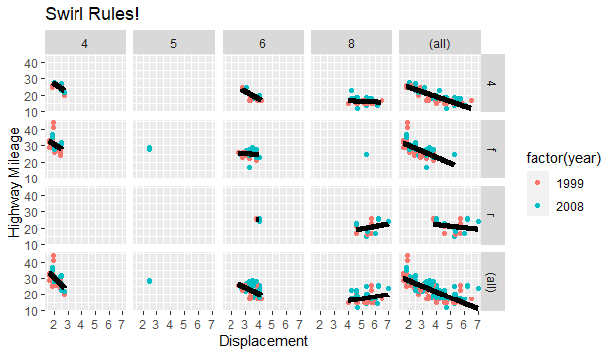

**GGlot2 extra**

**Data set diamonts**

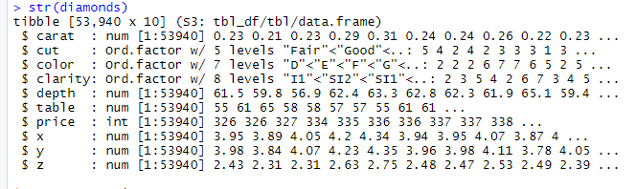

qplot(price,data=diamonds,binwidth=18497/30,fill=cut)

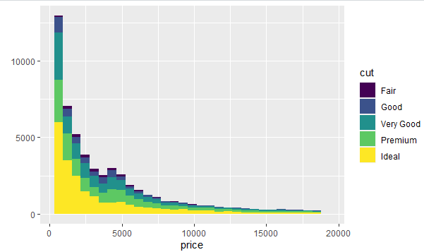

qplot(price,data=diamonds,geom="density",color=cut)

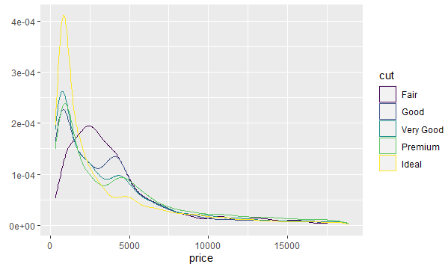

qplot(carat,price,data=diamonds, shape=cut)

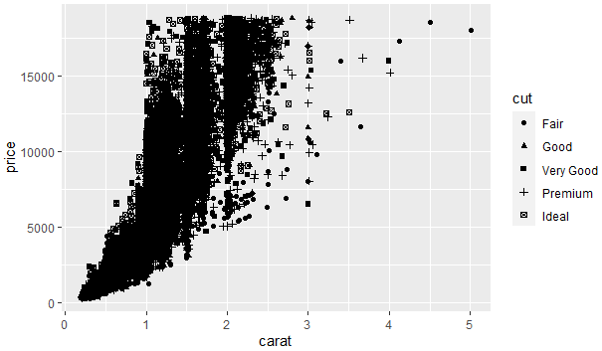

qplot(carat,price,data=diamonds, color=cut) + geom_smooth(method="lm")

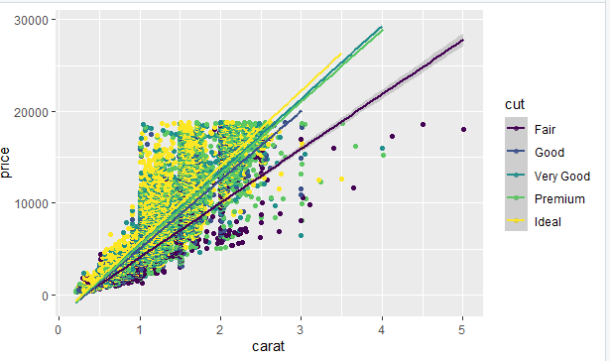

qplot(carat,price,data=diamonds, color=cut, facets=.~cut) + geom_smooth(method="lm")

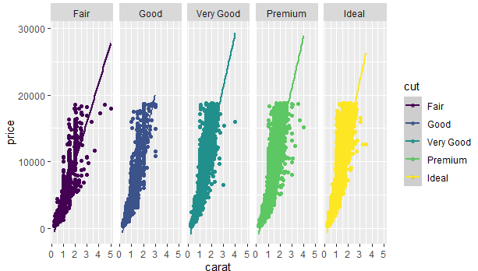

g <- ggplot(diamonds,aes(depth,price))

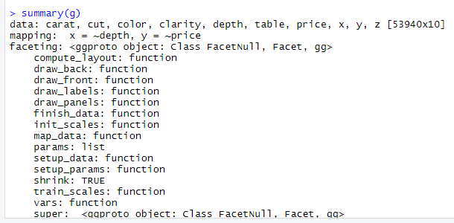

cutpoints <- quantile(diamonds$carat,seq(0,1,length=4),na.rm=TRUE)

diamonds$car2 <- cut(diamonds$carat,cutpoints)

g <- ggplot(diamonds,aes(depth,price))

g+geom_point(alpha=1/3)+facet_grid(cut~car2)

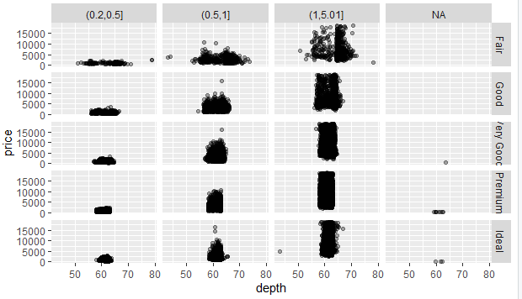

g+geom_point(alpha=1/3)+facet_grid(cut~car2)+geom_smooth(method="lm",size=3,color="pink")

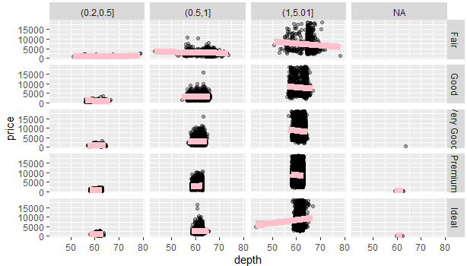

ggplot(diamonds,aes(carat,price))+geom_boxplot()+facet_grid(.~cut)

